Power analysis for survival and emigration of Upper Clark Fork brown trout
Donovan Bell

Overview
This document presents a power analysis for estimating survival and migration of juvenile brown trout in the Upper Clark Fork. We use a simplified model for the estimation of survival and migration of age-1 brown trout assuming fish are from one tributary, with one year of tagging, and migration out of one focal section. Bias and precision are examined under six scenarios with differing numbers of tagged fish, electrofishing detection probability, stationary scanner detection probability, survival probabilities, and emigration probabilities. Although simplified and likely optimistic, this power analysis suggests that obtaining juvenile survival and migration estimates of brown trout in the Upper Clark Fork could be feasible.

Methods
The current model assumes that N_{tagged} age-1 fish are captured in a screw trap and PIT tagged while entering the mainstem river at time t. We assume only downstream migration, with a single stationary PIT scanner installed downstream to estimate emigration from age-1 to age-2. Additionally, we assume that the section between the PIT scanner and the tributary’s confluence with the mainstem is sampled in its entirety using mark-recapture electrofishing one year later at time t+1. Note that if you assume survival and migration rates are the same among tributaries and across years, a greater number of tagged fish in this power analysis could represent grouping fish among tributaries and years.
Under these assumptions, the probability that a tagged fish is recaptured during electrofishing one year later is the probability of survival (survival) multiplied by the probability that the fish does not emigrate (1-emmigration) multiplied by the probability of detection of an age-2 fish during electrofishing (p_{efish}). The expected number of recaptures during electrofishing (N_{recaps_efish}) is the probability of individual electrofishing recapture multiplied by the number of fish initially tagged:
$${E[N}_{recaps_efish}]=N_{tagged}*survival*\left(1-emigration\right)*p_{efish}$$
Similarly, the probability that a tagged fish is scanned by the stationary PIT tag scanner is the probability of survival (survival) multiplied by the probability that the fish emigrates (emmigration) multiplied by the probability of detection given passage by the stationary PIT tag scanner (p_{array}). The expected number of fish scanned during emigration (N_{recaps_array}) is the total probability that a tagged fish is scanned by the PIT array multiplied by the number of fish initially tagged:
$${E[N}_{recaps_array}]=N_{tagged}*survival*emigration*p_{array}$$

The number of observed electrofishing and scanned recaptures is assumed to come from a binomial distribution with the number of trails equal to the number of tagged fish and the probability equal to the individual probabilities above. For example:
$$N_{recaps_array}=binomial(N_{tagged}, survival*emigration*p_{array})$$
Joint estimation of these equations allows for estimation of survival and emigration. We assume that both the electrofishing detection probability (p_{efish}) and stationary scanner detection probability (p_{array}) were already estimated (although these values could be simultaneously estimated). We also assume a standard deviation of 0.25 on the logit scale for both detection parameters to incorporate uncertainty in their estimation (see Fig. A1 for the distributions of these parameters).
We simulated observed datasets with the biological process fixed a known number of tagged fish, fish that survived, and fish that migrated. For the sampling process, we used a binomial random draw with the probability equal to the detection probability for the electrofishing and stationary scanner, and the number of trails equal to the number of fish that survived and stayed and survived and migrated, for the electrofishing and stationary scanner equation, respectively. These simulated datasets were then used to estimate survival and migration. Parameters were estimated in a Bayesian framework using the program JAGS.
We tested six different scenarios with differing numbers of tagged fish, survival and emigration probabilities, and detection probabilities (Table 1). The scenarios included a baseline based on expert biologist opinion of a likely scenario, and additional scenarios that deviated from the baseline in one category. We ran 200 iterations for each scenario.
Bias and precision were calculated for each scenario. Bias was defined as the mean deviation between the true and estimated parameter values. Parameter uncertainty was summarized as the mean standard deviation of the parameter estimates (similar to the mean standard error). Precision was assessed using the root mean squared error.

Table 1. Inputs in the different simulation scenarios, including the number of tagged fish, the true probability of survival and migration, and the electrofishing and stationary scanner detection probabilities.
Scenario | N tagged | p(survival) | p(migration) | E-fish p | Scanner p
1) Baseline | 500 | 0.3 | 0.05 | 0.3 | 0.8
2) 100 tagged | 100 | 0.3 | 0.05 | 0.3 | 0.8
3) 1000 tagged | 1000 | 0.3 | 0.05 | 0.3 | 0.8
4) Survival = 0.1 | 500 | 0.1 | 0.05 | 0.3 | 0.8
5) Migration = 0.5 | 500 | 0.3 | 0.5 | 0.3 | 0.8
6) E-fish p = 0.45 | 500 | 0.3 | 0.05 | 0.45 | 0.8

Results and Discussion
The baseline scenario shows promising accuracy and precision (Table 2; Figure 1). There was a small, positive bias in both survival and migration, but this low bias should still allow for reliable inference. The RMSE and mean SE of the estimates are both moderate to low. Increasing the sample to 1000 tagged fish causes a noticeable decrease in bias and increase in precision. Conversely, decreasing the sample size to 100 results in appreciably higher bias and lower precision. Increasing the electrofishing detection probability for 0.3 to 0.45 caused a small, but noticeable increase in precision.
This power analysis used a simplified system and should be interpreted as a likely optimistic baseline for understanding the expected bias and precision in this study. A better analytical approach would be to use a multi-state CJS survival model that allows for migration between sections, multiple years of data, and multiple tributaries. This could also integrate multiple data sources to increase precision. To obtain more reliable estimates of survival and migration, biologists should aim to tag as many fish as possible. However, in this simple scenario, the gains in precision from tagging 500 compared to 100 fish were much larger than the gains of tagging 1000 compared to 500 fish. Increasing detection probability through more pasess during electrofishing or having two sequential stationary scanners would also increase precision. Note that two sequential scanners would also allow for estimating the scanner detection probability, even seasonally, given sufficient migration occurs. Overall, this power analysis suggests that estimating juvenile survival and migration could be feasible in the Upper Clark Fork.

Table 2. Bias, mean stand error, and precision (root mean squared error) for all scenarios based on 200 simulation iterations.
Scenario | Bias survival | Bias migration | Mean SE survival | Mean SE migration | RMSE survival | RMSE migration
1) Baseline | 0.013 | 0.011 | 0.069 | 0.025 | 0.041 | 0.017
2) 100 tagged | 0.020 | 0.064 | 0.109 | 0.071 | 0.083 | 0.079
3) 1000 tagged | 0.007 | 0.006 | 0.060 | 0.018 | 0.027 | 0.010
4) Survival = 0.1 | 0.007 | 0.017 | 0.032 | 0.043 | 0.024 | 0.027
5) Migration = 0.5 | 0.012 | -0.003 | 0.048 | 0.073 | 0.030 | 0.043
6) E-fish p = 0.45 | 0.010 | 0.010 | 0.054 | 0.023 | 0.029 | 0.014

Figure 1. Boxplot of the estimates for survival and migration across the 200 simulation iterations shown for each scenario. Blue lines represent the true estimates.

Appendix
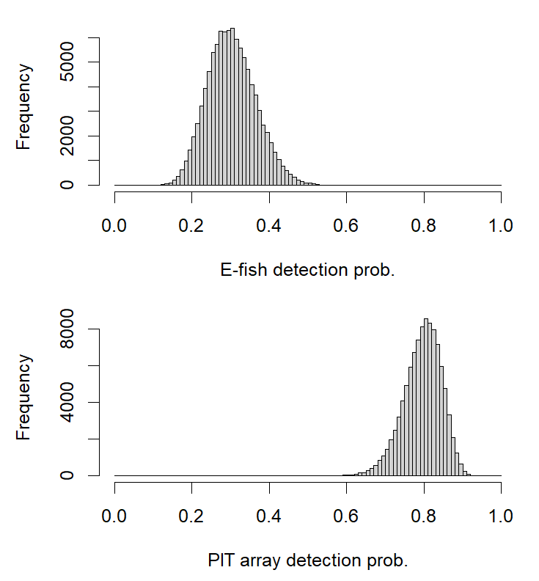
Figure A1. Histograms showing the distribution of parameter estimates used for detection probability in the JAGS model. These distributions were incorporated to include uncertainty in the detection probability estimates.

